Project Plan

**VicAccidentStats App**

***Taylor Edgerton***

***Davinder Grewal***

***Kiarna Broomhead***

Table of Contents

1.0 Introduction 3

1.1 Problem Background 3

1.2 Scope 3

1.3 Document contents 3

2.0 Work Breakdown Structure 4

3.0 Activity Definition & Estimation 5

4.0 Gantt Chart 6

# Introduction

## Background

Road accidents are avoidable and take a great toll on road users and the General public. Although the emotional toll of road accidents is enormous, there is also an exceedingly great cost to Governments and Tax Payers, in 2018 alone this cost was estimated to be more than $5 billion in fatalities and hospitalised casualties (Big data to crunch the numbers on road safety, 2022)

Governments provide educational resources about road accident statistics to the general public, as well as other initiatives In an attempt to curb road accidents through education and awareness. As well as using crash statistics for research purposes and for the development of road safety programs, The Victorian Government requires an application to analyse and process Victorian Road Accident Statistics between 2015 and 2020 for an upcoming educational initiative, which will be provided to learners and road users.

## Scope

The Road Accident Stats App will be written in Python 3.7, and provide a user with a graphical user interface for selecting search criteria and the program will output sorted information and models. The data the program will perform tasks on is limited to the Crash Statistics Victoria CSV file.

Required features of the program:

* Graphical user interface for users to select time periods and input accident keywords
* Display information of all accidents that happened during a user-selected period
* Produce a chart showing the average number of accidents in each hour of the day during a user-selected period
* Display all accidents caused by a user entered accident type keyword.
* Analyse trends of accidents due to alcohol
* Analyse trends of accidents involving motorcyclists and the road geometry

The program will not include data outside of the provided CSV file, or the output of information or charts other than specified.

## System Vision

### Problem Description

The Victorian Government regularly creates educational campaigns for drivers on Victorian Roads. A program is required to demonstrate to these drivers' organised data and visual representations of the data to aid in road use education and how and when accidents occur.

### System Capabilities

Graphical User Interface allowing users to select information and will proving organised and visual representation of Vehicle accident statistics. A simple user interface will allow many demographics of users to use the system. The system will utilise an already available CSV file of crash statistics. Python programming language will be used which is optimal for data analysis and data visualisation, and can be used on many operating systems, and has many data libraries to choose from.

### System Benefits

This proposed system can be rolled out to many workstations, laptop and tablets for use within Victorian main roads education offices. Graphical user interface will ensure user experience is simple and caters for a large demographic of people and ranging tech savviness. By implementing a graphical user interface, users do not require experience using python command lines. By utilising SQLite, a database is not required, only a CSV file.

## Document contents

This Project Plan contains project planning specific tools to ensure the project can be completed in the most efficient time period possible. A Work Breakdown Structure indicating the breakdown and duration of tasks required to complete the project is provided and indicates a task id, prerequisites of tasks, and the team members required to complete. Activity definitions and estimations are broken down and is then used to create a Gantt chart to monitor and review the critical path in order to delegate and schedule tasks accordingly. These charts will be updated iteratively as the project progresses.

# Work Breakdown Structure

**WORK BREAKDOWN STRUCTURE (WBS)**

|  |  |  |
| --- | --- | --- |
| **Level 1** | **Level 2** | **Level 3** |
| 1 VicAccidentStats App | 1.1 Initiating | 1.1.1 Assign Project Manager  1.1.2 Assign other team members  1.1.3 Initial meeting with Client |
|  | 1.2 Analysis | 1.2.1 Create scope plan  1.2.2 Create WBS and Gantt chart  1.2.3 Create activity definitions  1.2.4 Define and create Use Case diagram  1.2.5 Obtain approval from the Client |
|  | 1.3 Design | 1.3.1 Define system requirements  1.3.2 Define system components  1.3.3 Create system vision document  1.3.4 Define and Initiate GUI Design  1.3.5 Create Class Diagram  1.3.6 Create GUI wireframes and prototypes  1.3.7 Test GUI prototypes  1.3.8 Team meeting to conclude design tasks  1.3.9 Meet the client for design approval |
|  | 1.4 Build | 1.4.1 Initiate Git and GitHub Repository  1.4.2 Develop backend program code  1.4.3 Develop frontend program code  1.4.4 Test Code Backend  1.4.5 Rectify any issues from backend test  1.4.6 Test Code Backend  1.4.7 Rectify any issues from front end test |
|  | 1.5 Testing | 1.5.1 Test user experience  1.5.2 Conduct user acceptance test  1.5.3 Record test findings  1.5.4 Attend approval from the client for rollout |
|  | 1.6 Controlling | 1.6.1 Status reports  1.6.2 Update plans |
|  | 1.7 Closing | 1.7.1 Lessons learned  1.7.2 Prepare Final Report  1.7.3 Conduct project review in a team meeting |

Table 1.1 Work Breakdown Structure in Tabular Format

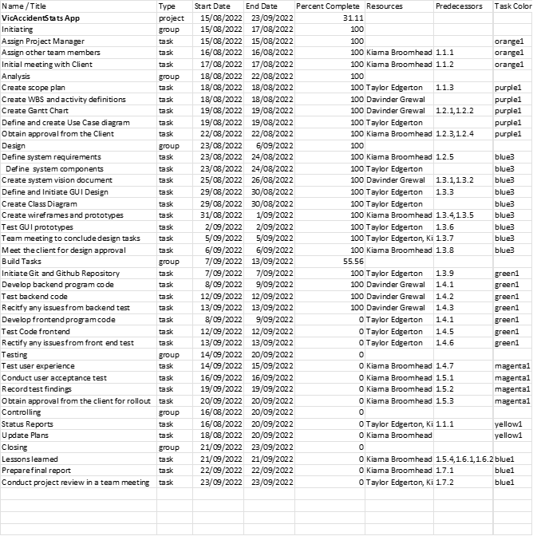

# Activity Definition & Estimation

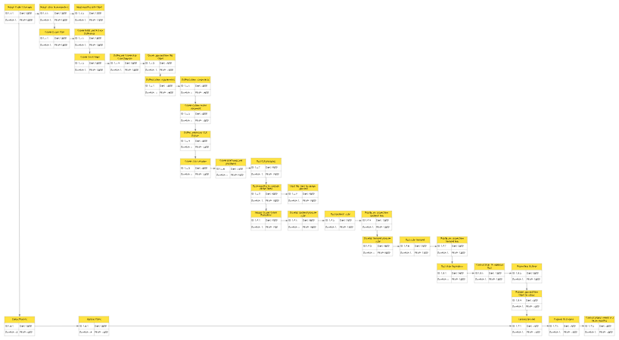

## Initiating Tasks

### Assign Project Manager – Duration 1 day

Decide and/or contact shortlisted Project Managers and assign the role.

### Assign other team members – Duration 1 day

Project Manager to determine roles required for the project and decide and/or contact shortlisted team members for a system’s analyst and a programmer.

### Initial meeting with Client – Duration 1 Day

Project manager to Meet with client to discuss the project scope, requirements and deadlines.

## Analysis Tasks

### Create Scope Plan – Duration 1 Day

Project manager to Create a scope plan according to the discussion with the client at the client meeting. This includes the project background and scope for inclusion in the project plan.

### Create WBS and activity definitions – Duration 1 Day

Project Manager to define tasks required to complete the project by creating a work breakdown structure, estimated schedule, task predecessors, milestones and task assignment according to the deadline.

**Create Gantt Chart – Duration 1 Day**

Project manager to determine activity definitions and descriptions of each task required.

### Define and Create Use Case Diagram – Duration 1 Day

Systems analyst to define Use Cases and create a Use Case diagram, ensuring the use of the new system and requirements are made clear in the Project Plan.

### Obtain approval from the Client – Duration 1 Day

Project manager to present the Project Plan to the Client for approval to commence design and build of the new system.

## Design Tasks

### Define System Requirements – Duration 2 Days

Functional requirements narrowed down from Use Case Diagram.

### Define System Components – Duration 2 Days

Systems analyst to Define system components, including frameworks, libraries or hardware required to meet the customers' requirements.

### Create System Vision Document – Duration 2 Days

System Vision Document commences defining the problem the system will solve, system capabilities and benefits this system will bring the client.

### Define and initiate GUI Design - Duration 2 Days

Graphical User Interface design begins, and user experience is analysed according to the use cases.

### Create Class Diagram – Duration 2 Days

Class Diagram is created determining the classes and backend design of the program.

### Create Wireframes and Prototypes – Duration 2 Days

Wireframes of the graphical user interface, and prototypes of the GUI are then created.

### Test GUI Prototypes – Duration 1 Day

GUI prototypes are tested by potential users of the system to ensure the client will be satisfied with the user experience.

### Team meeting to conclude design tasks – Duration 1 Day

Meeting with the team to ensure all design tasks are complete and are ready to be presented to the client for approval.

### Meet the client for design approval – Duration 1 Day

Project Manager to meet with the client for approval of the system design so Building can commence.

## Build Tasks

### Initiate GT and GitHub Repository - Duration 1 Day

Git and GitHub repositories are created and setup to ensure consistent version control and record keeping.

### Develop backend program code – Duration 2 Days

Back-end code is written providing the system with the logic according to the Use Cases, Class Diagrams and System Component Definitions.

### Test backend code – Duration 1 Day

Back End Code is tested iteratively during back-end program coding, and then tested for completion.

### Rectify any issues from backed test – Duration 1 Day

Any issues from back -end testing is rectified iteratively as well as after testing completion.

### Develop frontend program code – Duration 2 Days

Front end code is written providing the system with the GUI elements determined in the wireframes, prototypes, functional requirements and Use Cases.

### Test code Front End – Duration 1 day

Front End code is tested iteratively during Front End program coding, and then tested for completion.

### Rectify any issues from front end test – Duration 1 day

Any issues from Front End testing is rectified iteratively as well as after testing completion

## Testing Tasks

### Test User Experience – Duration 2 Days

User Experience is tested by suitable testers to ensure the client is satisfied with the user experience.

### Conduct user acceptance test – Duration 1 day

The system is presented to other possible and regular users of the system to evaluate broader acceptance of the system.

### Record test findings – Duration 1 day

Findings of the User Acceptance testing are recorded for the Client meeting

### Obtain approval from the client for rollout – Duration 1 day

The system and User Acceptance tests are presented to the Client for Final approval and handover of the system.

## Controlling Tasks

### Status Reports – Duration 26 days

Status reports and created by the team and provided to the Project Manager throughout the project iteratively and allow the Project Manager to evaluate the current status of the Project.

### Update Plans – Duration 24 days

Updates to the plans may be required throughout the project according to status reports.

## Closing Tasks

### Lessons Learned – Duration 1 day

Recording of problems and lessons learned to prevent these problems occurring in the future for including in the Final Report.

### Prepare final report – Duration 1 day

Final report of the project including problems that occurred, solutions to problems and what went well are contained in the Report.

### Conduct project review in a team meeting – Duration 1 day

Meeting with the team is conducted to discuss the final report for improvements for future projects.

# Gantt Chart

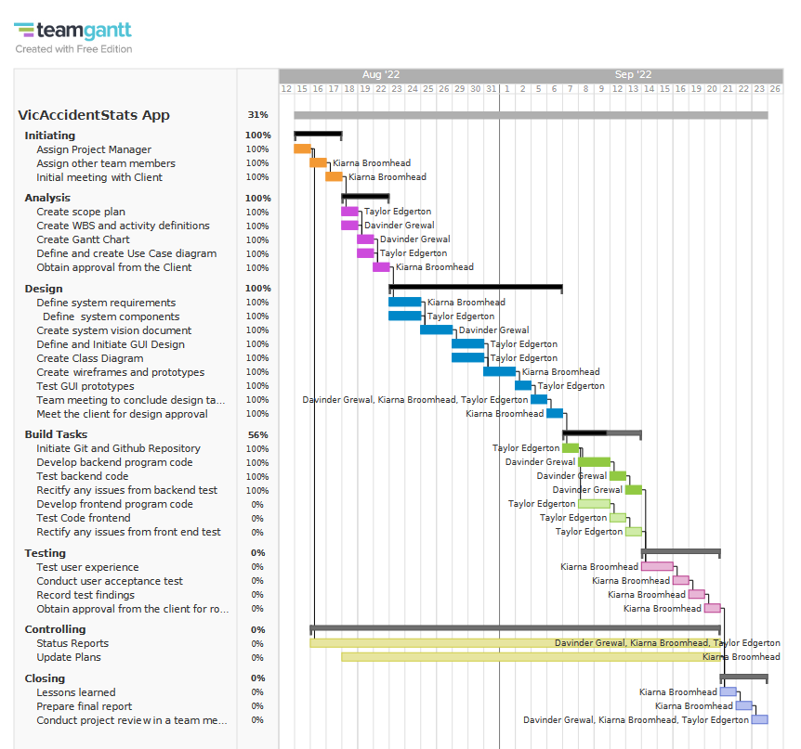

# References

The Queensland Cabinet and Ministerial Directory. 2022. *Big data to crunch the numbers on road safety*. [online] Available at: <https://statements.qld.gov.au/statements/88410#:~:text=Minister%20for%20Transport%20and%20Main%20Roads&text=%E2%80%9CIn%202018%2C%20the%20economic%20cost,billion%2C%E2%80%9D%20Mr%20Bailey%20said> [Accessed 4 September 2022].